**Jenkins Task**

**Task Description:**

Launch jenkins and explore creating projects and users.

**Techstacks needs to be used :**

* AWS EC2
* Jenkins

**Launched Jenkins Instance:**

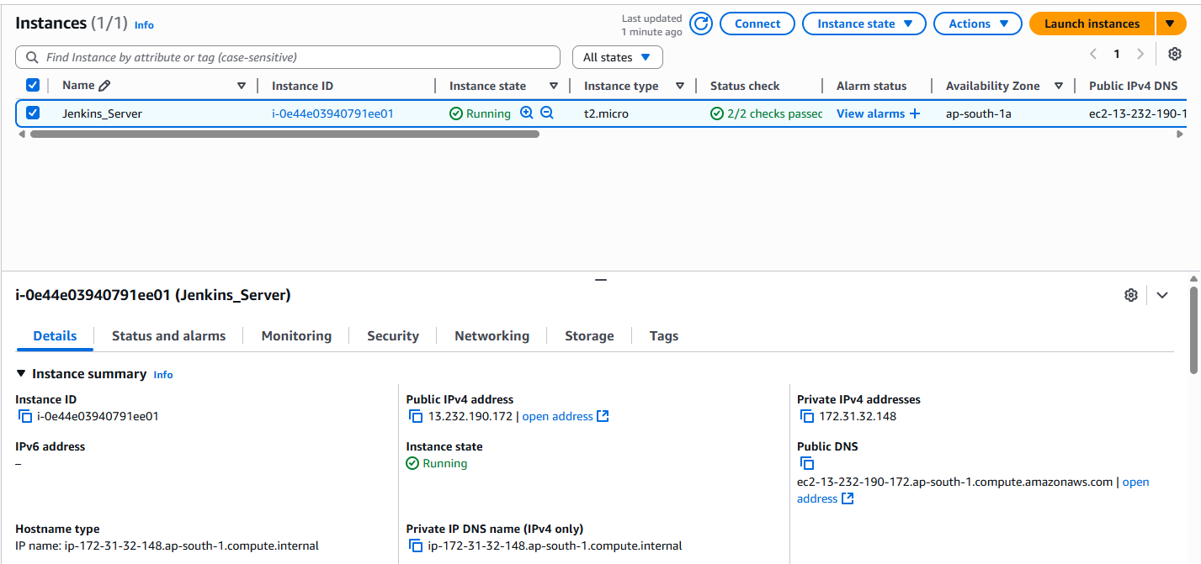  
  
  
**Installed Jenkins:**

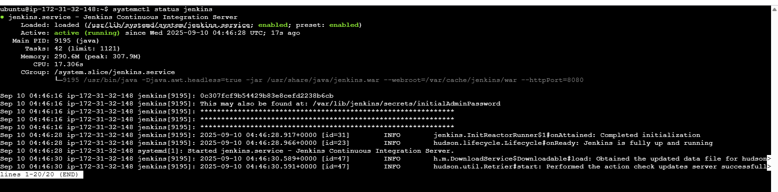  
  
  
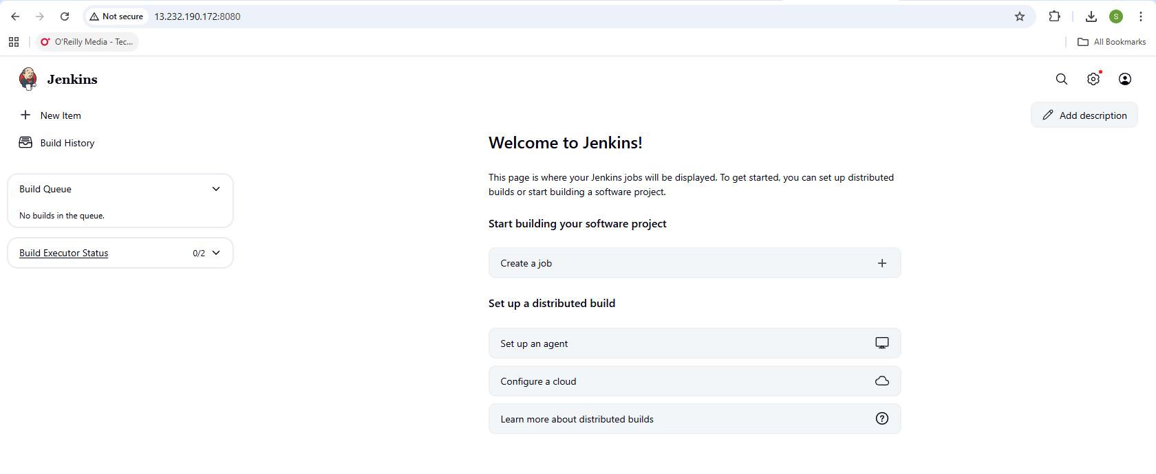  
  
  
**User account created:**

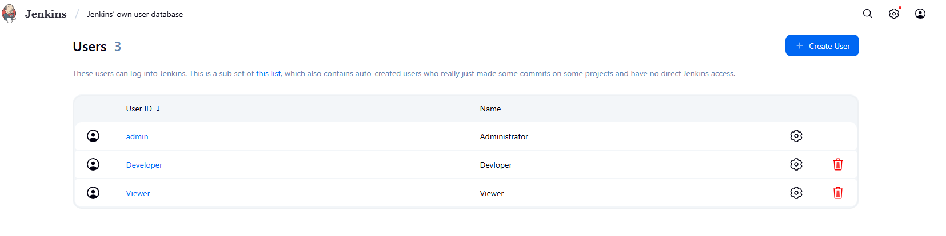

**Role-based Authorization Strategy Plugin installed:**

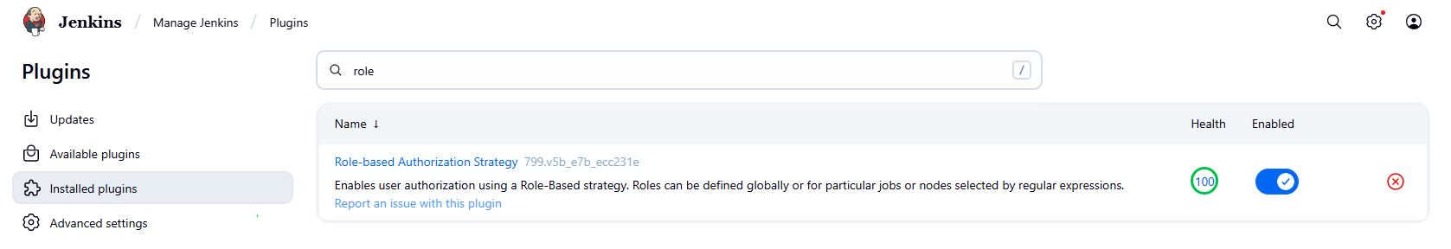  
  
  
**Role Created and assigned to users:**

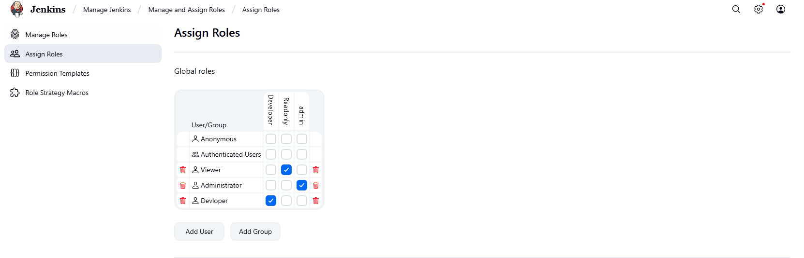

**Created Jenkins simple Projects (Jobs):-**  
  
  
